|  |  |
| --- | --- |
| **MSSV: 110122231** | **Mã lớp: DA22TTB** |
| **Họ tên: Hồ Lý Minh Lữ** | **Từ 16/12/2024 đến 22/12/2024** |
|  |  |

Hoàn thành thiết kế giao diện và chức năng

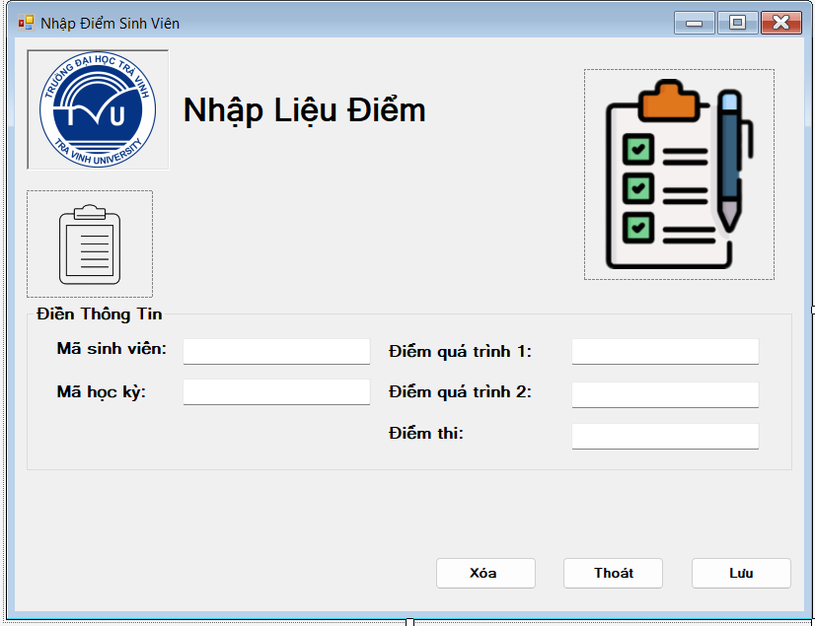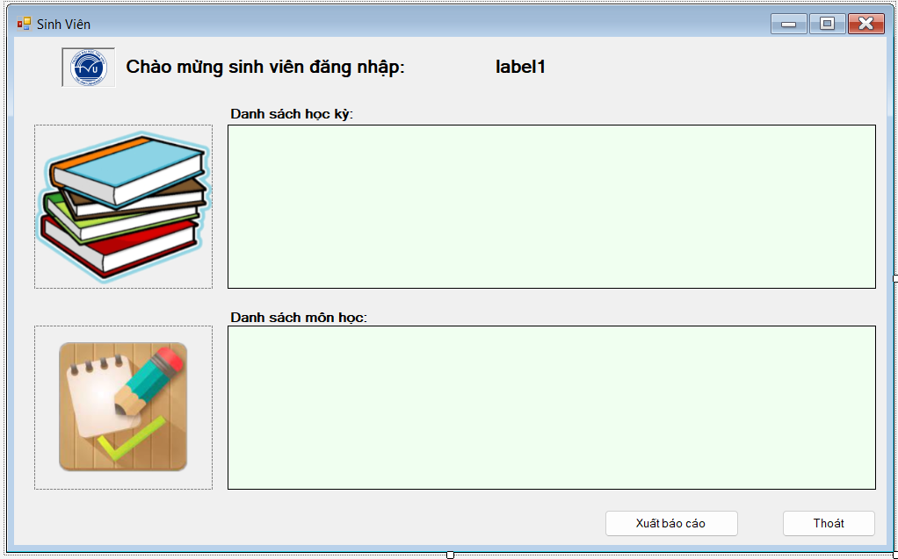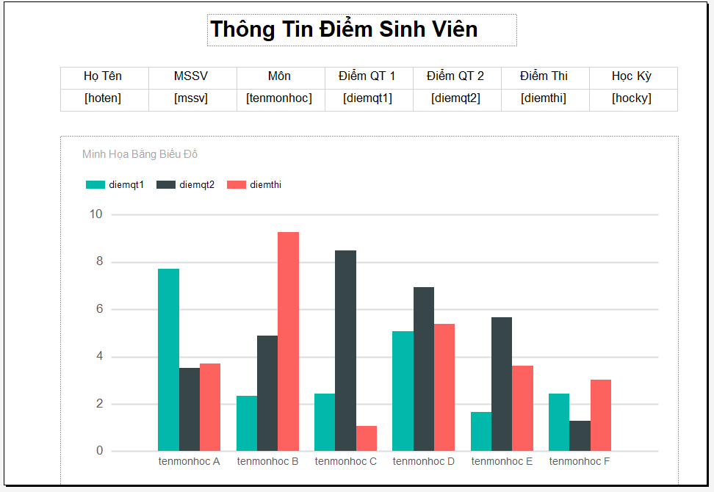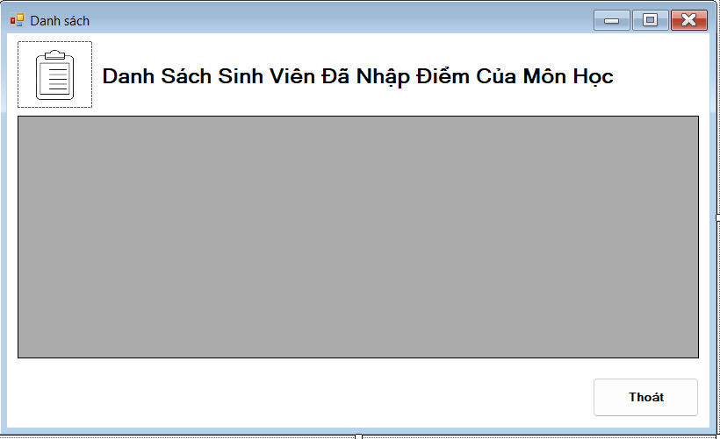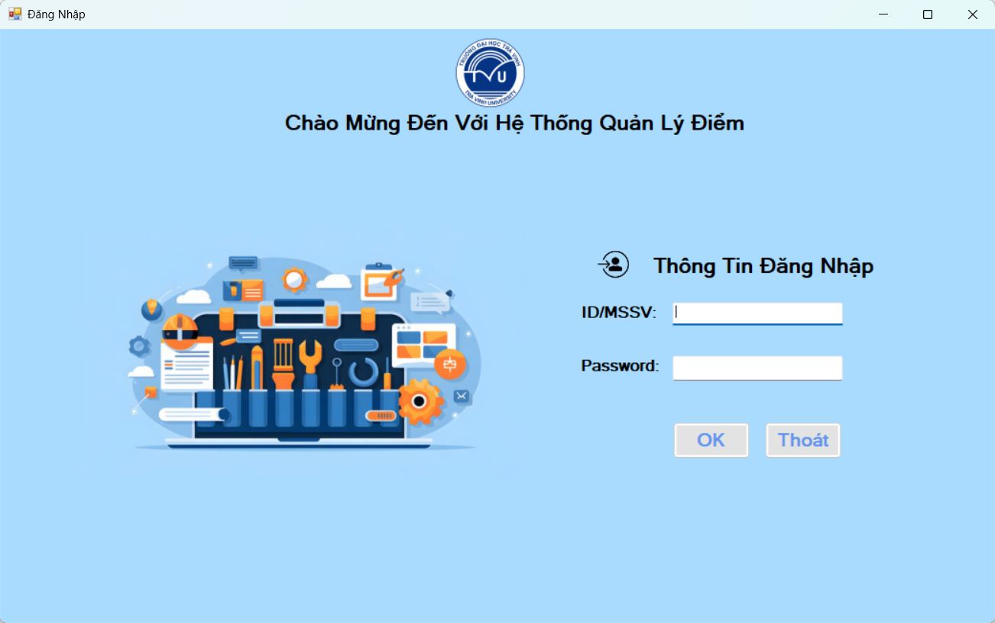

Hoàn thành thiết kế cơ sở dữ liệu:  
